# Software Engineering Assignment

**MODULE: 1 (SDLC)**

Submitted by Dhaval Bhatti

**1. What is software? What is software engineering?**- Software is a collection of programs, data, and instructions that tell a computer how to perform specific tasks. For example, Microsoft Word is a software that allows you to create and edit documents.  
  
  
- Software Engineering, on the other hand, is a field of engineering that focuses on designing, developing, testing, and maintaining software systems. It involves applying systematic approaches to ensure the software is reliable and efficient. For instance, if you were to build a new social media platform like Instagram, you'd use software engineering principles to design the app's interface, code its functions, test its performance, and update it regularly for improved user experience.

**2. Explain types of software.  
  
  
-** There are three main types of software:

* + **System Software:** These are the software that manage and control the computer hardware. They provide a platform for running application software. An example would be an operating system like Windows or Linux.
  + **Application Software:** These are programs designed for end-users to perform specific tasks. Examples include word processors like Microsoft Word or web browsers like Google Chrome.
  + **Programming Software:** These are tools used by developers to write, test, and debug other software. Examples include Integrated Development Environments (IDEs) like Visual Studio or Eclipse.

**3. What is SDLC? Explain each phase of SDLC  
  
  
-** The Software Development Life Cycle (SDLC) is a process used by the software industry to design, develop, and test high-quality software. It consists of six phases:

* + **Requirement Gathering and Analysis:** In this phase, all the relevant information from the client is gathered and analyzed to structure the project.
  + **Design:** Based on the requirements, the software's architecture is designed.
  + **Implementation/Coding:** The actual code for the software is written in this stage.
  + **Testing:** The software is tested for any bugs or issues.
  + **Deployment:** Once the software is fully ready and tested, it is deployed to the customer.
  + **Maintenance:** After deployment, the software may need regular updates and improvements.

**4. What is DFD? Create a DFD diagram on Flipkart  
  
  
-** A Data Flow Diagram (DFD) is a graphical representation of the data flow within a system. It shows how input data is transformed into output results through sequences of functional transformations.  
  
  
Here's a simple DFD for Flipkart:  
  
  
[Customer] --> (Browse Products) --> [Product Catalog]

[Customer] <-- (View Product Details) <-- [Product Catalog]

[Customer] <-- (Cart Page)

[Customer] --> (Checkout Page) --> [Order Processing]

[Order Processing] --> (Update Inventory) --> [Inventory Management]

[Order Processing] --> (Generate Invoice) --> [Customer]

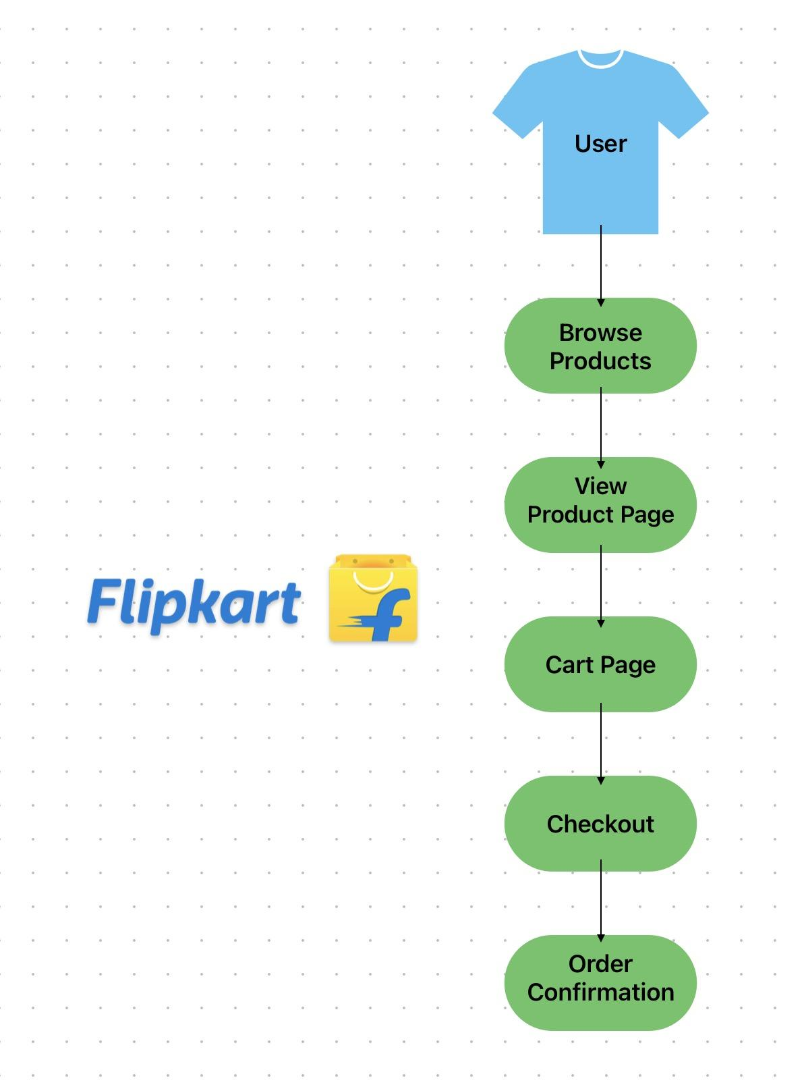

**5. What is a Flow chart? Create a flowchart to make the addition of two numbers.  
  
  
-** A flowchart is a type of diagram that represents an algorithm or process, showing the steps as boxes of various kinds and their order by connecting them with arrows.  
  
  
 Here's a simple flowchart for adding two numbers:  
  
  
Start

|

[Input Number1, Number2]

|

[Sum = Number1 + Number2]

|

[Output Sum]

|

End

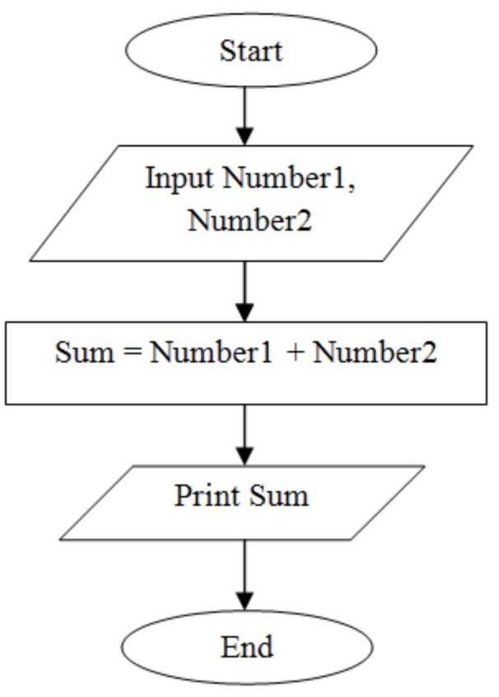

**6. What is a Use case Diagram? Create a use-case on the bill payment on Paytm  
  
  
-** A use case diagram is a visual representation of how a user might interact with a system. They show the relationships between users and the different use cases in which a user can interact with the system.  
  
  
Here's a simple use case for bill payment on Paytm:  
  
  
[User] --(Login into Paytm)--> [Paytm App]

[User] --(Select Bill Payment)--> [Paytm App]

[User] --(Enter Billing Details)--> [Paytm App]

[User] --(Confirm Payment)--> [Paytm App]

[Paytm App] --(Process Payment)--> [Bank]

[Bank] --(Confirm Transaction)--> [Paytm App]

[Paytm App] --(Notify User)--> [User]

